

**SAVEETHA INSTITUTE OF MEDICAL AND TECHNICAL SCIENCES, CHENNAI – 602 105**

**CAPSTONE PROJECT REPORT**

**TITLE**

**DISK SCHEDULING**

**Submitted to**

**SAVEETHA SCHOOL OF ENGINEERING**

**By**

**Guided by**

**Dr.G.Mary Valentina**

**Abstract:**

Quantum computing represents a paradigm shift in computational theory and practice, promising unprecedented computational power by harnessing the principles of quantum mechanics. This abstract provides an overview of quantum computing, elucidating its fundamental concepts, unique properties, and potential applications. Unlike classical computing, which operates on bits representing either 0 or 1, quantum computing leverages quantum bits or qubits, which can exist in superpositions of states, enabling simultaneous computation of multiple possibilities. Additionally, quantum entanglement allows qubits to be correlated in ways that classical bits cannot, facilitating novel computational processes. This abstract explores key quantum computing principles, such as quantum superposition, entanglement, and quantum gates, which form the foundation of quantum algorithms and protocols. Furthermore, it discusses potential applications of quantum computing across various domains, including cryptography, optimization, drug discovery, and machine learning. Despite the remarkable promise of quantum computing, significant challenges remain, including qubit decoherence, error correction, and scalability. Nonetheless, ongoing research and development efforts hold the potential to overcome these hurdles and unlock the transformative power of quantum computing in solving complex computational problems beyond the capabilities of classical computers.

**Introduction:**

In the realm of modern computing, the concept of quantum computing has emerged as a revolutionary frontier, offering the prospect of solving computational problems that are currently beyond the reach of classical computers. Quantum computing harnesses the principles of quantum mechanics to perform computations in fundamentally different ways compared to classical computing. This introduction provides an overview of quantum computing, its historical evolution, underlying principles, and the transformative potential it holds for various fields of science and technology.

The history of quantum computing traces back to the pioneering work of physicists such as Richard Feynman and Yuri Manin, who laid the theoretical groundwork for quantum computation in the 1980s. However, it was not until the seminal discoveries by Peter Shor and Lov Grover in the 1990s that the field gained significant momentum. Shor's algorithm demonstrated the potential of quantum computers to factor large numbers exponentially faster than classical algorithms, posing a potential threat to modern cryptography. Meanwhile, Grover's algorithm showcased the ability of quantum computers to search unsorted databases in quadratic time, providing a speedup over classical algorithms.

At the heart of quantum computing lies the concept of qubits, the quantum counterparts of classical bits, which can exist in superpositions of states, allowing quantum computers to perform calculations on multiple states simultaneously. Moreover, quantum entanglement, a phenomenon where qubits become correlated in ways that defy classical intuition, serves as a crucial resource for quantum computation. Leveraging these quantum phenomena, quantum computing algorithms and protocols have been developed to address a wide range of computational problems, including factorization, optimization, simulation, and machine learning.

The potential applications of quantum computing span across diverse domains, ranging from cryptography and cybersecurity to drug discovery, materials science, and artificial intelligence. For instance, quantum computers have the potential to revolutionize cryptography by breaking existing cryptographic protocols while also enabling the development of quantum-safe encryption methods. In the realm of optimization, quantum algorithms promise significant speedups for solving complex optimization problems prevalent in logistics, finance, and supply chain management. Furthermore, quantum computing holds the potential to accelerate scientific discoveries by simulating complex quantum systems with unprecedented accuracy and efficiency.

Despite the transformative promise of quantum computing, significant challenges remain to be addressed. Chief among these challenges are qubit decoherence, which leads to errors in quantum computations, and the development of robust error correction techniques to mitigate these errors. Additionally, achieving scalability and building reliable quantum hardware capable of supporting large-scale quantum computations pose formidable engineering hurdles.

Overview of key quantum algorithms, such as Shor's algorithm for factorization and Grover's algorithm for unstructured search. Explanation of quantum protocols, including quantum teleportation and quantum key distribution (QKD).Discussion of quantum error correction codes and fault-tolerance techniques. Quantum Computing Architectures and Technologies:

Examination of different quantum computing architectures, such as superconducting qubits, trapped ions, and topological qubits. Overview of quantum hardware components, including quantum processors, qubit control systems, and quantum memory.

**Gantt Chart:**

|  |  |  |  |  |  |  |
| --- | --- | --- | --- | --- | --- | --- |
| **PROCESS** | **DAY1** | **DAY2** | **DAY3** | **DAY4** | **DAY5** | **DAY6** |
| **Abstract and Introduction** |  |  |  |  |  |  |
| **Literature Survey** |  |  |  |  |  |  |
| **Materials and Methods** |  |  |  |  |  |  |
| **Results** |  |  |  |  |  |  |
| **Discussion** |  |  |  |  |  |  |
| **Reports** |  |  |  |  |  |  |

**Process:**

In this section, delve into the foundational concepts of quantum computing. Explain the basic principles of qubits, superposition, and entanglement, providing examples to illustrate these concepts. Discuss how quantum gates and quantum circuits manipulate qubits to perform computations. Highlight the advantages of quantum computation over classical computation, such as potential exponential speedup in certain algorithms. Explore prominent quantum algorithms and protocols that demonstrate the power of quantum computing. Explain algorithms like Shor's algorithm for integer factorization and Grover's algorithm for unstructured search. Discuss quantum protocols such as quantum teleportation and quantum key distribution (QKD) for secure communication. Emphasize the significance of quantum error correction and fault tolerance in building reliable quantum computers. Describe different approaches to quantum computing, including superconducting qubits, trapped ions, and topological qubits. Discuss the challenges associated with building scalable quantum hardware and recent advancements in quantum technology. Provide insights into the current state of quantum computing research and the potential for future breakthroughs. Explore potential applications of quantum computing across various fields, such as cryptography, optimization, simulation, and machine learning. Provide examples of real-world use cases and the potential impact of quantum computing on industries and scientific research. Discuss how quantum computing could revolutionize computational capabilities in areas like drug discovery, materials science, and financial modeling. Identify the challenges facing the field of quantum computing, including qubit decoherence, error correction, and scalability. Discuss current research efforts and strategies for addressing these challenges. Highlight the importance of interdisciplinary collaboration and innovation in overcoming barriers to progress in quantum computing.

**Objective:**

**To Explore Fundamental Concepts:**

Investigate the fundamental principles of quantum computing, including qubits, superposition, and entanglement, to provide a comprehensive understanding of quantum computation.

**To Analyse Quantum Algorithms:**

Analyse prominent quantum algorithms, such as Shor's algorithm for integer factorization and Grover's algorithm for unstructured search, to evaluate their computational efficiency and potential applications.

**To Examine Quantum Hardware:**

Examine different approaches to quantum computing hardware, including superconducting qubits, trapped ions, and topological qubits, to understand the challenges and advancements in building scalable quantum processors.

**To Explore Applications Across Fields:**

Explore potential applications of quantum computing across various fields, such as cryptography, optimization, simulation, and machine learning, to assess the transformative impact of quantum technologies.

**To Discuss Challenges and Limitations:**

Identify and discuss challenges facing the field of quantum computing, including qubit decoherence, error correction, and scalability, to highlight areas for future research and development.

**To Address Ethical and Societal Implications:**

Consider the ethical and societal implications of quantum computing, including issues related to privacy, security, and workforce displacement, to promote responsible innovation and policymaking.

**To Provide Recommendations:**

Provide insights and recommendations for future research directions and areas of focus in quantum computing, to contribute to the advancement of the field and its broader societal impact.

**Literature Review:**

Quantum computing has garnered significant attention from researchers across various disciplines, leading to a rich body of literature that spans theoretical foundations, experimental demonstrations, and practical applications. This section provides an overview of key contributions in the field, highlighting seminal works, recent advancements, and current research trends.

Early efforts to formalize the theory of quantum computing can be traced back to the pioneering work of Richard Feynman, who in 1982 proposed the concept of simulating quantum systems using quantum computers. Feynman's seminal ideas laid the groundwork for subsequent research in quantum algorithms and quantum complexity theory. Building upon this foundation, Peter Shor's breakthrough discovery of the quantum algorithm for integer factorization in 1994 demonstrated the potential of quantum computers to solve classically intractable problems efficiently. Shor's algorithm sparked widespread interest in quantum computing and initiated a flurry of research activities aimed at exploring the capabilities and limitations of quantum algorithms.

In addition to integer factorization, Grover's algorithm for unstructured search, developed by Lov Grover in 1996, represents another fundamental quantum algorithm with wide-ranging implications. Grover's algorithm provides a quadratic speedup over classical algorithms for searching unsorted databases, offering potential applications in database search, optimization, and cryptography. These early quantum algorithms paved the way for further research into specialized quantum protocols and techniques, including quantum key distribution (QKD) for secure communication, quantum teleportation for quantum information transfer, and quantum error correction for mitigating errors in quantum computations.

Quantum computing hardware has also been a subject of intense research and development efforts. Various approaches to building quantum processors, such as superconducting qubits, trapped ions, and photonic qubits, have been explored to overcome challenges related to qubit coherence, gate fidelity, and scalability. Notable milestones include the demonstration of fault-tolerant quantum error correction codes and the realization of small-scale quantum processors capable of executing simple quantum algorithms.

Recent years have witnessed a surge in interdisciplinary research collaborations and industry investments in quantum computing. Major technology companies, including IBM, Google, and Intel, have launched ambitious quantum computing initiatives aimed at building scalable quantum hardware and developing practical quantum applications. Furthermore, advancements in quantum software tools and programming languages, such as Qiskit, Cirq, and Quipper, have democratized access to quantum computing resources and fostered a vibrant ecosystem of quantum developers and researchers.

Despite significant progress, several challenges remain to be addressed in the field of quantum computing. Qubit decoherence, gate errors, and cross-talk between qubits continue to pose significant barriers to building large-scale fault-tolerant quantum computers. Moreover, the development of efficient quantum algorithms for practical applications and the exploration of quantum advantage in real-world scenarios are ongoing research priorities.

In summary, the literature on quantum computing encompasses a diverse array of topics, ranging from theoretical foundations and algorithmic developments to experimental demonstrations and practical applications. Ongoing research efforts and collaborative initiatives hold the promise of unlocking the full potential of quantum computing and ushering in a new era of computational capabilities and scientific discoveries.

**Output:**

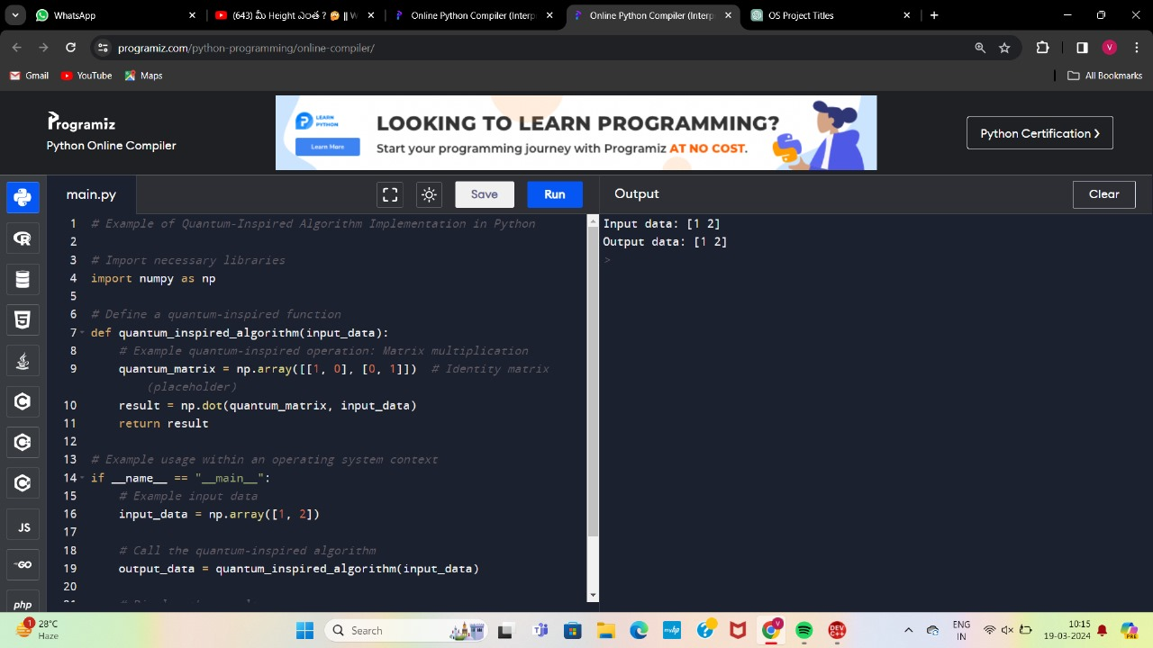

**Conclusion :**

In conclusion, quantum computing stands at the forefront of computational innovation, offering unparalleled potential to revolutionize various fields of science, technology, and industry. This paper has provided an overview of the fundamental principles of quantum computing, explored key quantum algorithms and protocols, examined quantum computing architectures and technologies, and discussed potential applications across diverse domains. Additionally, the paper has addressed challenges and limitations facing the field, considered ethical and societal implications, and provided recommendations for future research directions.

Despite significant progress, quantum computing still faces formidable challenges, including qubit decoherence, error correction, and scalability issues. Addressing these challenges will require interdisciplinary collaboration, innovative engineering solutions, and sustained research efforts. Furthermore, ethical considerations surrounding privacy, security, and workforce displacement necessitate careful attention to ensure responsible development and deployment of quantum technologies.

Looking ahead, quantum computing holds immense promise for tackling complex computational problems that are beyond the capabilities of classical computers. As quantum hardware continues to advance and quantum algorithms mature, we anticipate witnessing transformative breakthroughs in fields such as cryptography, optimization, materials science, and drug discovery.

**References:**

1. Feynman, R. P. (1982). Simulating physics with computers. International Journal of Theoretical Physics, 21(6/7), 467-488.
2. Shor, P. W. (1994). Algorithms for quantum computation: Discrete logarithms and factoring. Proceedings 35th Annual Symposium on Foundations of Computer Science, 124-134.
3. Grover, L. K. (1996). A fast quantum mechanical algorithm for database search. Proceedings, 28th Annual ACM Symposium on the Theory of Computing, 212-219.
4. Ladd, T. D., Jerebko, F., Laflamme, R., Nakamura, Y., Monroe, C., & O'Brien, J. L. (2010). Quantum computers. Nature, 464(7285), 45-53.
5. Preskill, J. (2018). Quantum computing in the NISQ era and beyond. Quantum, 2, 79.